Are the following substances produced (or purchased ready-made):
- 4,4,5 – trimethyl-1,3-dioxane-5-ol [dioxane alcohol];
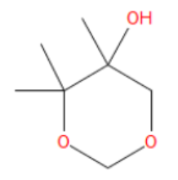

- (4,5-dimethyl-1,3-dioxane-4-yl )methanol [dioaxane alcohol];;

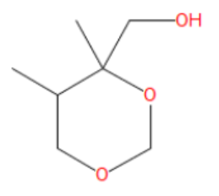
- 1-ethyldecyl acetate [ester];
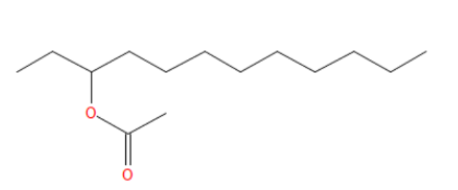
- Allyl 2-ethyl butyrate [ester];
